

1809170001, 916110105, 1710240005

Hospital (Doctor)

KImseng Houy , SHEKINA KADIONGO, LEROY MASWAURE

Report

2019

Contents

Abstract 2

Introduction 3

ER 3

Implementation 4

UML 5

Conclusion 5

# Abstract

This report will have focused on how doctor keeps their patient information and what the doctor does in the hospital. The objective of the report was to identify the way of doctor maintain their work and keep their information in one place safely. The findings of the report that doctor that can keep the data and information in the patient visit doctor table. It will know everything when the patient comes, patient test or medicine and room. The finding concludes that the main thing to keep the data not repeat that allow doctor know everything just search in once time.

# Introduction

We all know the hospital is big and has many employees such as the Nurses, medical teams and trainees. However, the most important person is the Doctor who has many roles such as to test patients and is also involved in leading a medical team, supervising a trainee, and is also a head of a department. So, the main question is how can data be kept in one place? In this project, we will focus what doctor do in the hospital and keep their work so accurately, and show how can it be done easily.

## ER

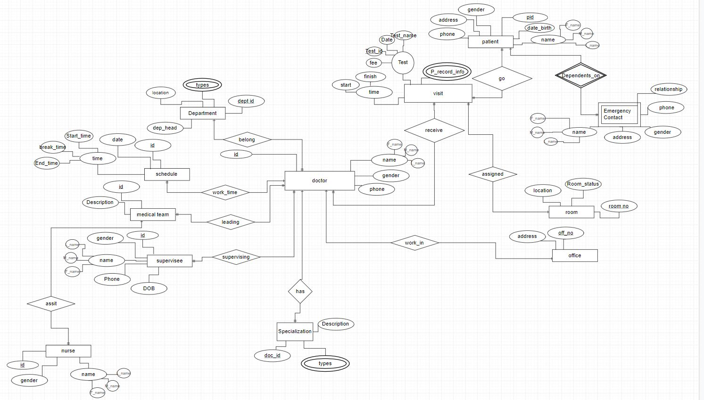

# Implementation

In our database we have 10 entities and 1 weak entity. The 10 entities are Department, Medical team, Supervisee, Doctor, Nurse, Patient, Schedule, Office, Test and Specialization and 1 weak is Emergency Contact. First, we explain about relationship between Department and Doctor. The Doctor has an id, Name, Gender, and phone. The Department has an id, Department head, Name and location. We mark them as 1:M relationship because 1 department can have many doctors and a doctor can be a Department head also so a 1:1 relationship because there can only be 1 head of Department. The Doctor leads a medical team with a 1:N relationship because 1 doctor can lead many medical teams and 1 medical team lead by 1 doctor. A Doctor can also supervise many supervisees so a table with attributes such supervisee id, Name, Gender, Phone, DOB and This relationship is a 1:N relationship, however 1 supervisee can only be supervised by 1 doctor supervising many supervisees and 1 So a 1:1 relationship created in a new table called Doctor_supervising_supervisee. The Doctor has a Schedule that has an id, date, start time and End time. We mark as M:N relationship too because 1 doctor can have many schedules and vice versa. A new table named Doctor_Scehdule will be created, this table shows the Doctors schedule by searching the doctor_id if they are available on a particular time. A Doctor has an office show by a 1:1 relationship because 1 Doctor works in 1 office. A Doctor works on Patients. A Patient has an id, name, phone, gender, address, and DOB and the relationship between a Doctor and Patient would be a M:N relationship Because many Patients visit many Doctors and many Doctors attend many patients. This is shown by a table called Patient_visit_Doctor . In this table we can find out what Doctor is visited by the Patient, which room the Patient is assigned to, the test taken by a Patient and the Patient records. Some Doctors have Specialization, in specialization there is type and description of specialization and doctor_id so that we know which specialization refers to which doctor. We mark 1:M relationship because 1 doctor can have many specializations. When the doctor wants to contact the patient friends or family. The doctor can know by the Emergency Contact that has patient_id, name, address, gender, phone, and relationship. This table will have relationship of the patient and the emergency contact and this is a weak dependency. Room and Test is linked to the Patient_visit_Doctor table because all information about the room and test is stored in that table. The room has Room status that can let people know if the room is occupied or not. The Nurse can be part of many Medical Teams so a 1:M relationship will be created. We marked a 1:N relationship because and 1 medical team have many nurses.

## UML

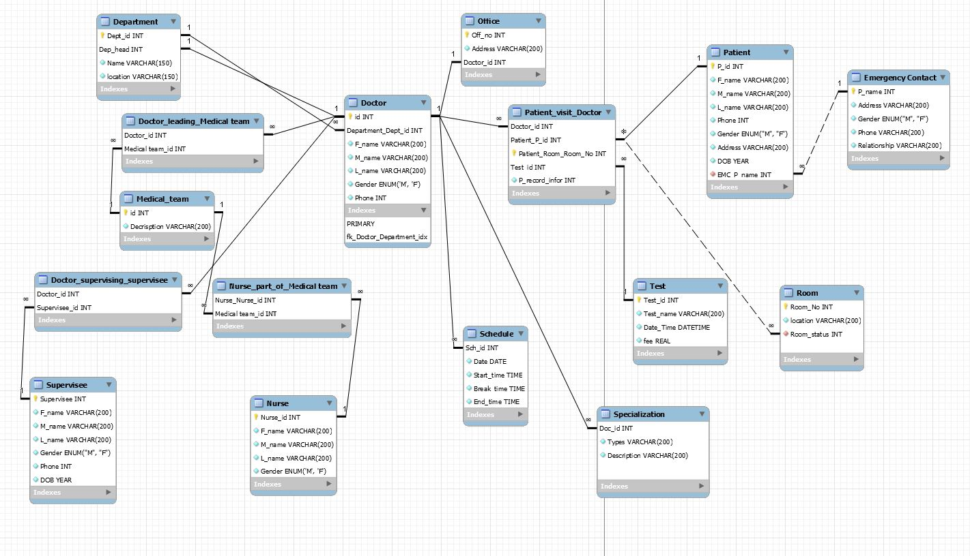

# Conclusion

In conclusion, we can keep or maintain all the doctor data in one place so that data is easy to access for the Doctor and avoiding clutter and index fragmentation and benefits in the hospital having regular updates of its in patients and out patients.The database will help the Doctor to have access to all the information of the patients, the nurses available , who the doctor is supervising and the medical team the doctor is leading.